Delete account flow

Flow diagram
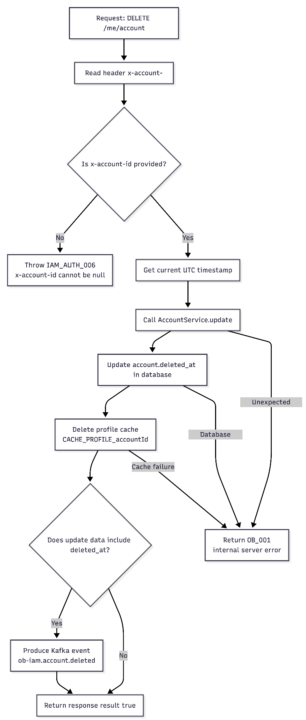

Preview Screen
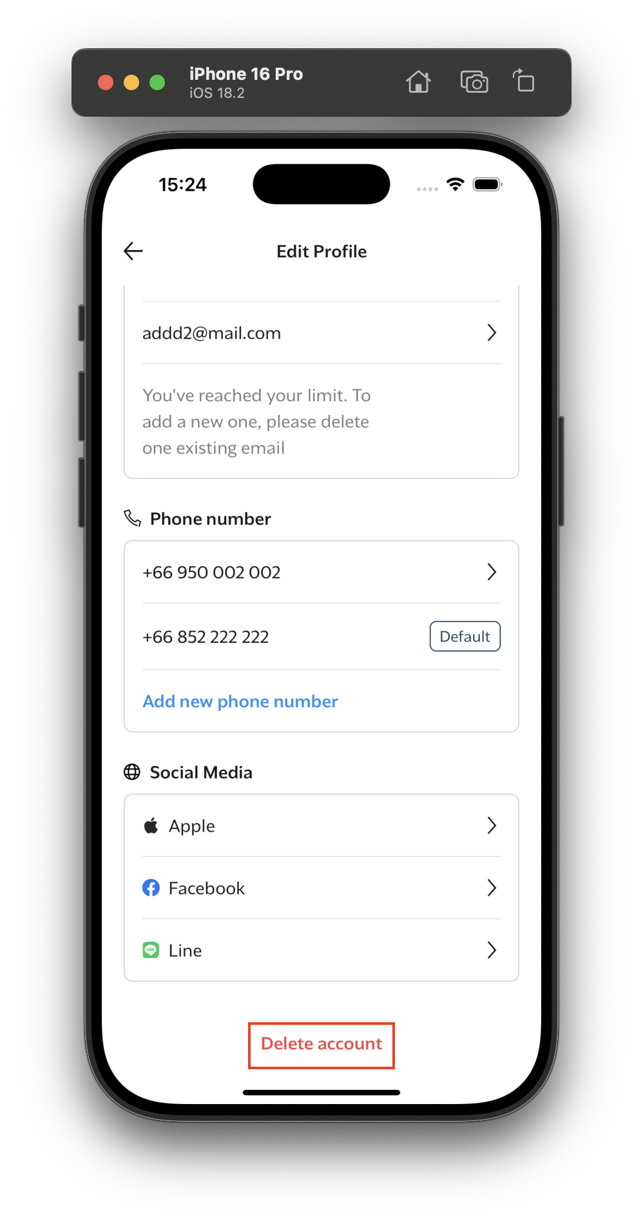
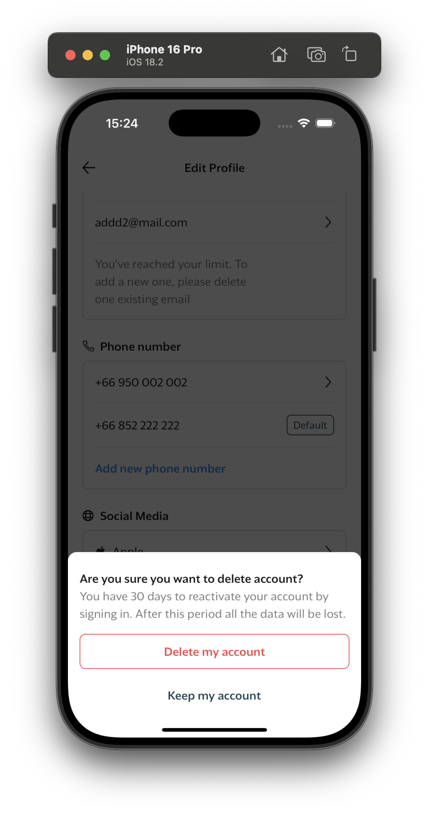

Sequence diagram
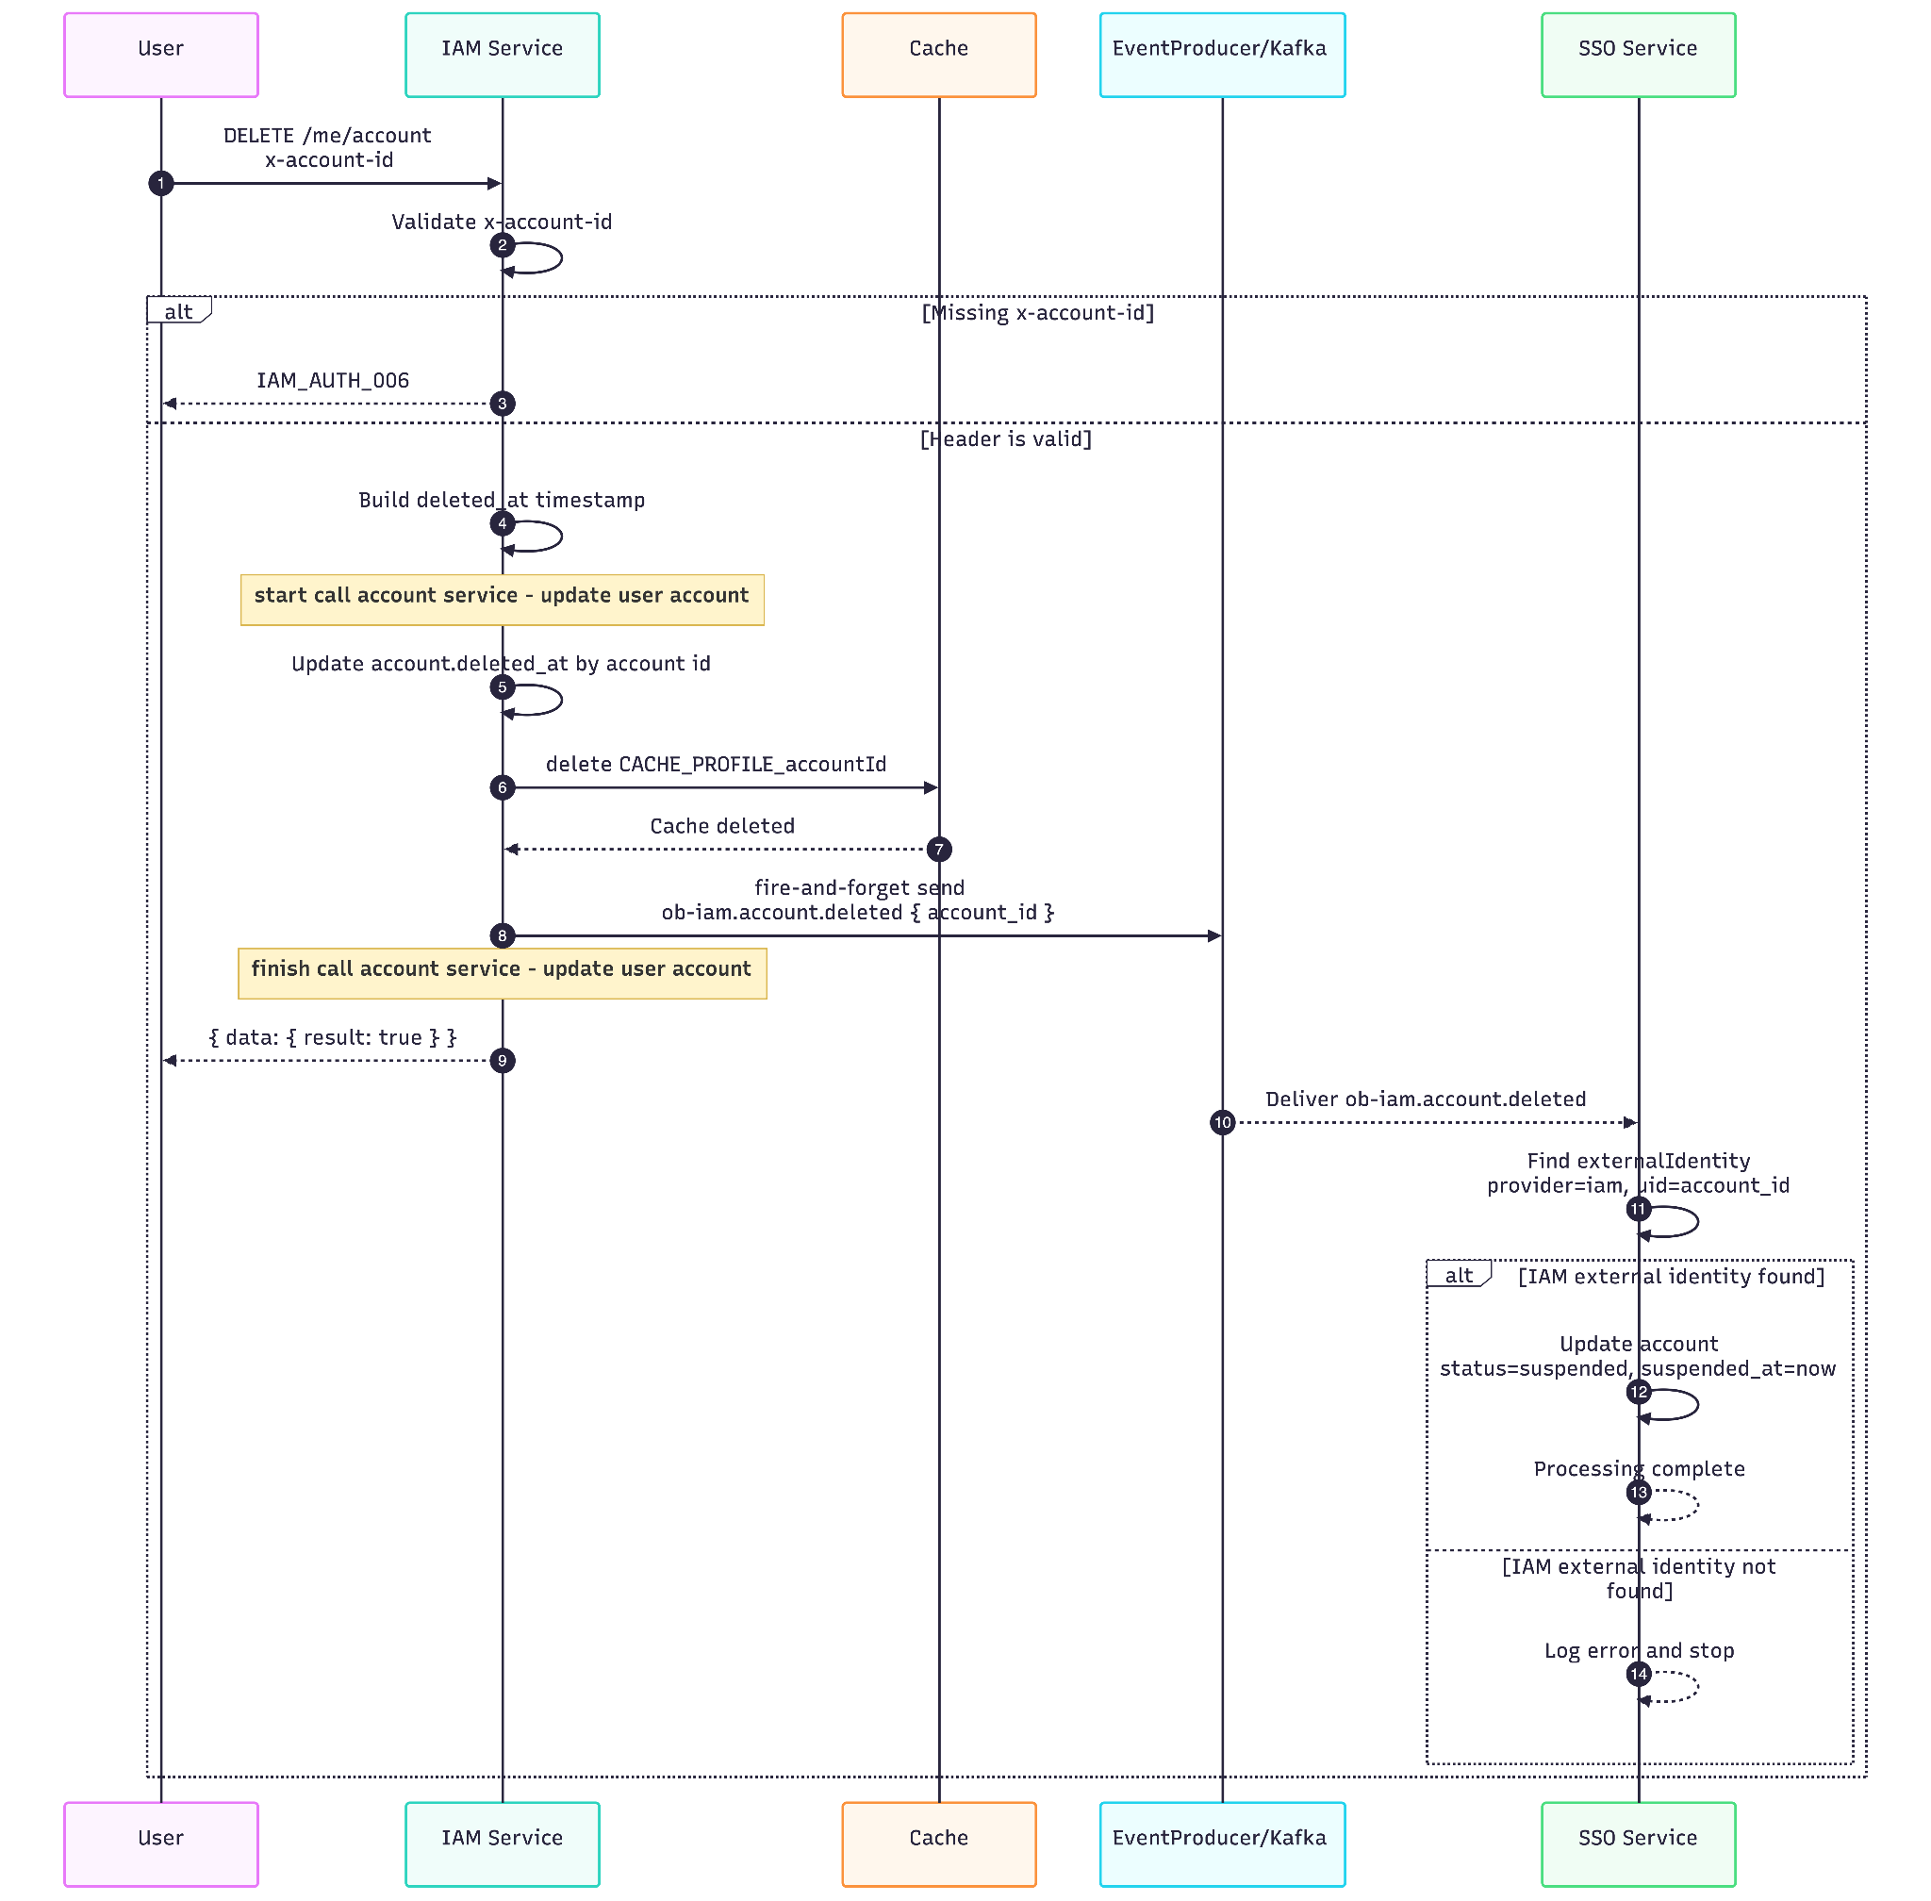

Api description - IAM

Description
Deactivate an authenticated user's account by marking it as deleted.

Example Request
DELETE /me/account HTTP/1.1
x-account-id: 123e4567-e89b-12d3-a456-426614174000

Headers Required
Header | Type | Required | Description
x-account-id | string | Yes | The account ID that should be deactivated.

Success Response
{
"data": {
"result": true
}
}

Response detail: result true means deactivate account success.

Error Scenarios
Error Code | HTTP Status | When It Occurs | User Action
IAM_AUTH_006 | 500 | Missing x-account-id header | Ensure the request includes the account ID header
OB_001 | 500 | Unexpected internal failure during account update, cache cleanup, or event publishing | Retry the request; if it persists, contact support

Error Response Examples

500 - Missing Account ID (IAM_AUTH_006)
{
"error": {
"code": "IAM_AUTH_006",
"message": "x-account-id cannot be null",
"stack": "Error\n at AccountController.delete (/src/controllers/account_controller.ts:54:13)\n at ..."
}
}

500 - Internal Server Error (OB_001)
{
"error": {
"code": "OB_001",
"message": "internal server error",
"stack": "Error: Connection timeout\n at AccountService.update (/src/services/account_service/index.ts:713:11)\n at AccountController.delete (/src/controllers/account_controller.ts:59:5)\n at ..."
}
}

Api description - SSO

Description
The ob-iam.account.deleted Kafka event consumed by the SSO service.
The event is published by IAM when an IAM account is deleted or deactivated from IAM's side. SSO consumes the event and suspends the corresponding local SSO account so the user can no longer continue as an active account in SSO.

Event Name
ob-iam.account.deleted

Event Structure
{
"name": "ob-iam.account.deleted",
"payload": {
"account_id": "string"
}
}

Payload Details
Field | Type | Required | Description
account_id | string | Yes | IAM account ID. SSO matches this value with external_identities.uid where provider = "iam".

Example Event
{
"name": "ob-iam.account.deleted",
"payload": {
"account_id": "8f7f7f9e-8a4e-4d0e-b49f-96d9c2e6527a"
}
}

Cache key

Key | TTL | Source | Purpose
CACHE_PROFILE_{accountId} | 7200 seconds | AccountService via CACHE_PROFILE_KEY | Cached IAM profile payload. Deleted after account.deleted_at is updated.

